|  |
| --- |
| For best navigation, click on the table of contents to navigate and click on and header or subheader to return to the table of contents. Otherwise, use the Document Outline feature (to the left on PC, or the top right ellipsis drop-down menu on the mobile app).  **This document is a collaborative resource. Contributions welcome! Did we miss a key study? Please add it! We definitely won't be watching all of the oral presentations, so please supplement this information if you watch the oral abstracts.**  Click on any information within [brackets] for a direct link to PubMed.  Trials that have been previously published will have the new information from ASCO underlined. |

# Table of Contents

**Table of Contents** **1**

**Breast** **1**

ER-positive or DCIS 1

HER2+ 2

TNBC 2

**CNS** **2**

**Peds** **2**

**GI** **3**

**Gyn** **5**

**Non-Prostate GU** **5**

**Prostate** **6**

**H&N, Thyroid** **7**

**Skin** **7**

**Heme** **8**

**Sarcoma / Musculoskeletal** **8**

**Thorax** **9**

## 

## Breast

[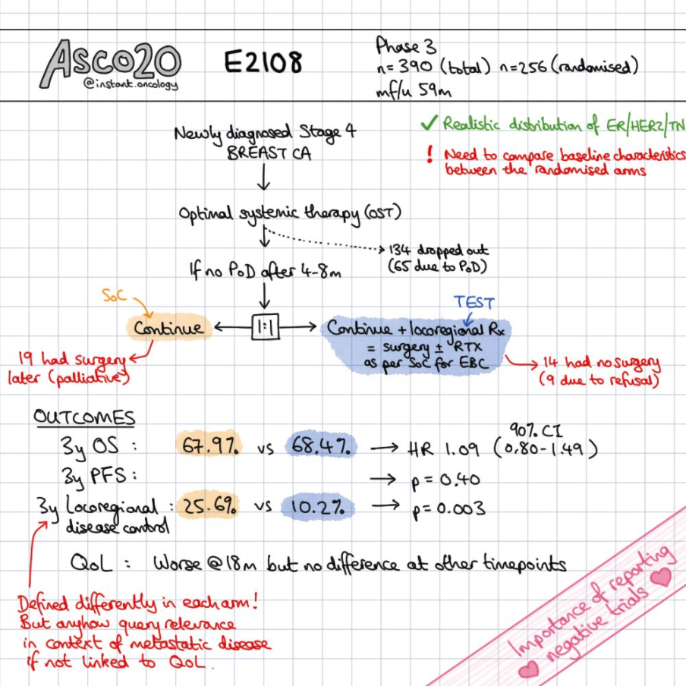](https://www.instagram.com/p/CA3SG9aApds/?utm_source=ig_web_copy_link)

* **E2108** (2011-2015) [[Khan ASCO ‘20](https://meetinglibrary.asco.org/record/186884/abstract)]: **Systemic treatment ± locoregional therapy (Surgery/RT)**.

The Betting Line [QS](http://www.quadshotnews.com/2020/05/e2108.html): Surgery and/or radiation after response to initial chemotherapy will improve overall survival for women with de novo metastatic breast cancer and resectable primary disease—but this may be driven by certain receptor subtypes.

TBL [QS](http://www.quadshotnews.com/2020/06/eeeeh-2108.html): We steered you wrong if you bet that locoregional therapy for women with stage IV breast cancer improves survival, but it could very well be due to lack of patient selection.

Caveat: Treatment of the primary in metastatic cancer has a suggested OS benefit for Prostate cancer with low-volume disease. [RoR](https://docs.google.com/document/d/1j15zXLBPWwqty60Slm2jnHEiqaoT2iw5Gapp4iMWJsw/edit#heading=h.ist6wess1k3f) Importantly, E2108 does not tease out the volume of disease.

* + 256 pts. De novo stage IV breast cancer without progression on chemo x4-8 mo. Resectable primary. MFU 5y.
  + 3y OS ~68%.
  + 3y LRR (or LR progression) 26→ 10%.
  + HRQoL was worse at 18 mo in the LRT, but no difference was observed at time points 6 or 30 mo.

### ER-positive or DCIS

* **NSABP B-43** (2008-2014) [[Flowchart](http://www.nsabp.pitt.edu/B-43.asp), [NCT00769379](https://clinicaltrials.gov/ct2/show/NCT00769379), [Cobleigh ASCO ‘20](https://meetinglibrary.asco.org/record/184894/abstract)]: **BCT ± Trastuzumab** IV w1, w4.

HER2/neu is considered a weak prognostic indicator in DCIS.

* + 2014 patients. MFU 6.5y.
  + Annual IBTR of ~1→ 0.8%.
* **MINDACT** (2007-2011)[[Cardoso NEJM '16](http://www.nejm.org/doi/full/10.1056/NEJMoa1602253), [ASCO ‘20](https://meetinglibrary.asco.org/record/184901/abstract)]: **High clinical risk, low genomic risk→ ± chemo**.Microarray In Node 0-3 Disease may Avoid CTX. Utilizing 70 gene assay for 0-3 nodes.

Genomic low risk can de-escalate care in clinical high risk, but genomic HR does not trump clinical LR.

TL;DR - Mammaprint can downswing treatment in clinical high risk, but cannot upswing treatment in clinical low risk.

* + 6993 women, T1/2, operable T3. LR/HR by Mammaprint & clinical risk (Adjuvant online). MFU nearly 9y.
    - Low clinical/low genomic risk→ no chemo. 5y OS w/o DM 97.6%
    - **Low/High or High/low→ ± chemo**. 1,550 pts high clinical risk and low genomic risk.

Endpoint: Noninferiority 5y OS w/o DM of 92%.

* + - High clinical/high genomic risk→ chemo. 5y OS w/o DM 90.6%
  + For clinical HR and genomic LR:

This could avoid adjuvant chemo if clinical high risk and genomic low risk in 46% of patients (almost half of clinical high risk are Mammaprint low risk).

* + - 5y OS w/o DM 96.2→ 94.7%, 8y OS 95.7→ 94.3%. *There is a 1.5% detriment for withholding chemo.*
    - 5y DMFS 96→ 95%, 8y DMFS 92→ 89.4%. *There is a 2.6% detriment for withholding chemo.*
  + For genomic HR and clinical LR, equivalent 5y OS w/o DM.
* Palbociclib may be used with letrozole or fulvestrant [[PARSIFAL Llombart-Cussac ASCO ‘20](https://meetinglibrary.asco.org/record/184813/abstract)]
* **BYLieve** [[Rugo ASCO ‘20](https://meetinglibrary.asco.org/record/186927/abstract)]: Phase II. **Fulvestrant + PI3K inhibitor** (Alpelisib).
  + 127 patients progressing on CDKi + AI. All had PI3K mutations. MFU 1y.
  + 6 mo PFS 50%.
  + Most frequent AEs include diarrhea (60%), hyperglycemia (58%), nausea, fatigue, decreased appetite, and rash.

### HER2+

* **Pyrotinib** is an irreversible pan-ErbB inhibitor. It appears to be superior to lapatinib in combination with capecitabine for patients with HER2+ metastatic breast cancer [[PHOEBE Xu ASCO ‘20](https://meetinglibrary.asco.org/record/184810/abstract)]

[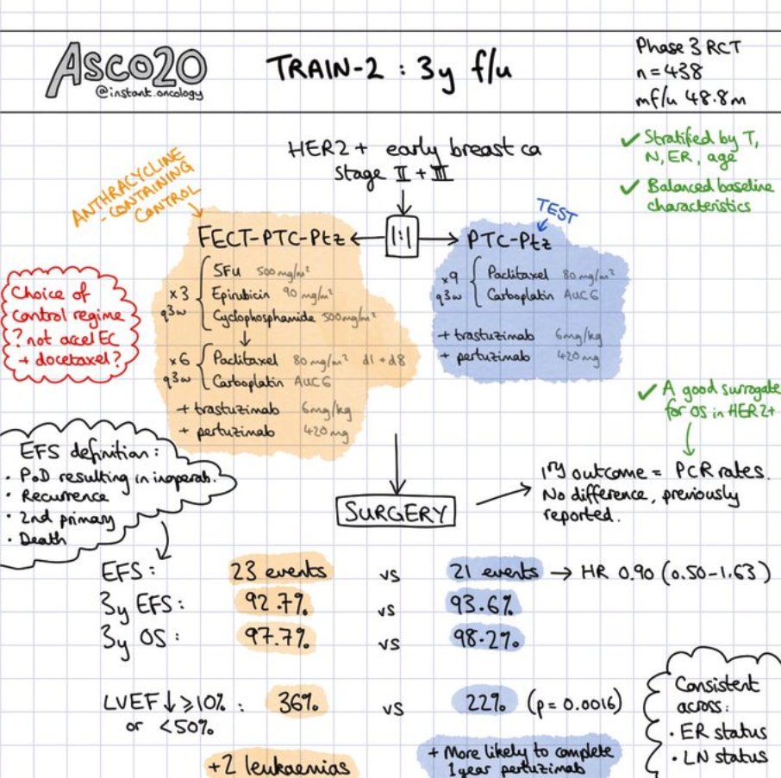](https://www.instagram.com/p/CAyYqYKgfUu/?utm_source=ig_web_copy_link)

* **TRAIN-2** [[van der Voort ASCO ‘20](https://meetinglibrary.asco.org/record/184908/abstract)]: (**FEC x3c→ CarboT x6c vs. CarboT x9c**) **with Trastuzumab and Pertuzumab**.

Carboplatin and Paclitaxel appear to be very promising for HER2 positive breast cancer.

* + 438 patients. Stage II-III **HER2 positive** breast cancer. MFU 4y.
    - FEC-PC: 5-FU 500, epirubicin 90, CPM 500 x3c → Carbo AUC 6, paclitaxel 80 d1,8 x6c.
  + 3y EFS ~93%. 3y OS ~98%.
  + LVEF decline ≥ 10% of 9→ 3%.
* **HER2CLIMB** [[Murthy NEJM '19](https://www.nejm.org/doi/full/10.1056/NEJMoa1914609), [Lin JCO '20](https://pubmed.ncbi.nlm.nih.gov/32468955/)]: **Previously rec'd HP and T-DM1→ Trast/Capecitabine ± Tucatinib**.

TBL [QS](http://www.quadshotnews.com/2019/12/new-heights.html): The addition of tucatinib to capecitabine and trastuzumab improves PFS and OS among patients who progress on the big HER2-three (i.e., Herceptin, Perjeta, and Kadcyla), including those with brain metastases.

* + 612 HER2(+) metastatic pts. Brain metastasis in 50% (n=291). Excluded LMD.
    - Tucatinib is a highly selective oral HER2 TKI.
    - Included patients with asymptomatic or previously treated brain metastasis.
  + 1y PFS 12→ 33%. MPFS 6→ 8 mo.
  + Brain mets cohort: 1y PFS 0→ 24%. MCNS-PFS 4→ 10 mo. MIC-DOR 3→ 7 mo. MS 12→ 18 mo.
  + 1y OS 27→ 45%. MS 17→ 22 mo.
  + One of the many interesting side effects of tucatinib is that it increases serum creatinine without affecting GFR. Something to ponder when ordering your surveillance imaging.

### TNBC

* Adjuvant capecitabine appears to be important in TNBC, improving 5y DFS by 10% [[SYSUCC-001 Wang ASCO ‘20](https://meetinglibrary.asco.org/record/184912/abstract)]
* **KEYNOTE 355** [[Cortes ASCO ‘20](https://meetinglibrary.asco.org/record/184800/abstract)]: **Chemo ± Pembro**.
  + 847 pts. Metastatic TNBC with ≥ 6 mo DFI. MFU 1.5y.
  + CPS ≥ 10 with MPFS of 6→ 10 mo.

## 

## CNS

* **A071401** [[NCT02523014](https://clinicaltrials.gov/ct2/show/NCT02523014), [Brastianos ASCO '20](https://meetinglibrary.asco.org/record/185074/abstract)]: SMO/AKT/NF2 mutated and progressive. **FAK inhibition**.

PFS6 efficacy endpoint was met in both the grade I and grade II-III cohorts.

* + 36 patients of 322 patients screened. Meningiomas.
  + Grade I patients with 6y PFS of 83%.
  + Grade I-II patients with 6y PFS of 33%.

## Peds

* Dexrazoxane has cardioprotective effects, especially for ≥ 300 mg/m2 of anthracyclines [[Chow ASCO '20](https://meetinglibrary.asco.org/record/185877/abstract)].
* **ANBL 1531** [Ongoing]: EFS with 131-MIBG ± crizotinib (14% ALK) during induction prior to tandem ASCT.

See an excellent powerpoint discussion of neuroblastoma protocols [[Haas-Kogan COG 2016](https://www.qarc.org/COG/Neuroblastoma_.pdf)].

Inhibition of ALK-driven NB w lorlatinib appears to be efficacious with manageable toxicity [[Goldsmith ASCO '20](https://meetinglibrary.asco.org/record/185854/abstract)].

* + Lots of radiation questions! *If tumor proximity to VB, then should cover entire VB + posterior elements to 18 Gy.*
  + Should we decrease our margins for CTV and PTV?
  + What should our sup/inf pre-chemotherapy volumes be?
  + Should we only expand into areas where the tumor was before chemo?
  + Should we decrease upfront surgery treatment volumes?
  + Should we change deviation criteria and normal tissue constraints?
  + Should we increase the metastatic dose to 36 Gy if persistently MIBG avid?
  + Should the hypofractionation option be explored for metastatic lesions (e.g., 3 Gy)?
  + Normal tissue constraint changes.
* 5y EFS for kids ≥ 18 mo with Stage III MYC-NA UH NB (high risk) is ~70%, with 5y OS ~80%. 10y EFS for ± 11q loss/LOH of 45→ 78% and 10y OS for ± 11q loss/LOH of 62→ 86%. There was also a trend towards worse EFS and OS for 1p loss/LOH and 2p gain, but not OS [[Pinto ASCO '20](https://meetinglibrary.asco.org/record/185860/abstract)].
* The pediatric precision oncology study INFORM: Clinical outcome and benefit for molecular subgroups [[Tilburg ASCO '20](https://meetinglibrary.asco.org/record/185853/abstract)]
  + 1300 patients enrolled. Relapsed/refractory/progressive disease. 525 patients included in analysis. Median age 12.
  + Relevance of alterations very high (8%), high (15%), moderate (20%), intermediate (24%), borderline (14%), low (2.5%), very low (1%) and no actionable target (15%).
  + 149 patients received targeted treatment, of which 20 had a high priority target (mostly ALK, BRAF, and NRAS mutations and MET and NTRK-fusions).
  + MPFS for ± targeted treatment of 114→ 205 days. OS did not differ.
  + Exploratory analysis of TTP ratio demonstrated patients treated for very high priority target had a higher TTP ratio compared to all other patients.

## 

## GI

* **FLOT-4** [[JCO '17](http://ascopubs.org/doi/abs/10.1200/JCO.2017.35.15_suppl.4004), [Al-Batran Lancet ‘16](https://doi.org/10.1016/S1470-2045(16)30531-9), ['19](https://www.sciencedirect.com/science/article/pii/S0140673618325571)]: Phase II/III. **Peri-op ECF/X** (3/3) **vs. FLOT** (4/4). **D2** (median 25 LN).

Periop FLOT (taxane) now standard of care!  
Rationale: Survival is poor with ECF, and many pts cannot complete ECF.

A phase II trial has suggested more pts may proceed to surgery if Ramucirumab is added to FLOT [[RAMSES ASCO '20](https://meetinglibrary.asco.org/record/185988/abstract)]  
The addition of HP to HER2+ disease appears to at least double rates of pCR and nodal clearance [[PETRARCA ASCO '20](https://meetinglibrary.asco.org/record/186001/abstract)]

* + 716 pts. Gastric (44%) or GEJ (56%). ≥ cT2 or N+ resectable. Over 2/3 cT3, 80% N+.
    - ECF/X x3→ Surgery→ ECF/X x3. Epirubicin 60, CDDP 50, infusional 5-FU 200 or capecitabine 1.25g.
    - FLOT x4→ Surgery→ FLOT x4. FLOT: 5-FU 2.6g CI, LV, Oxaliplatin 200, Docetaxel 85.
  + FLOT had 50% completion of post-op, while ECF/ECX had ~40% like MAGIC.
  + MS 35→ 50m, 3y OS 48→ 57%. 5y OS 36→ 45%.
  + R0 78→ 85%. 90% went to surgery.
  + pCR 6→ 16%.
  + Serious AE 27% around surgery for both groups, toxic deaths < 1%.
  + Hospitalization for toxicity in 25%.
  + ECX/ECF more likely to have N/V/D thromboembolic while FLOT more immunosuppressive and neuropathy.
* **RTOG 1010** [[Protocol](https://www.rtog.org/LinkClick.aspx?fileticket=52jdx-MJBUQ=&tabid=290), [Safran ASCO '20](https://meetinglibrary.asco.org/record/185991/abstract)]: Phase III. **50.4/28 with CarboP ± Trastuzumab**.

Esophageal 10% HER2, but up to 33% if GEJ (compared to 20% for stomach, higher if intestinal type) [[ToGA JCO '09](http://ascopubs.org/doi/abs/10.1200/jco.2009.27.15s.4556)].

Unlike the addition of perioperative HP to FLOT, the addition of trastuzumab to CCRT did not improve outcomes.

* + 571 assessed, 203 HER2+ randomized (35%). Esophageal AC from mid esophagus to Siewert III. MFU 5y.
    - Trastuzumab 4 mg/kg w1→ 2 mg/kg x5w during CCRT. 6 mg/kg x1 prior to surgery, 6c q3w x13 adjuvant.
    - Constraints:
      * Spinal cord: 45 Gy.
      * Liver V30 < 60%. MLD 25 Gy.
      * Kidney V20 < 70%.
      * Heart V40 < 50%. MHD 30 Gy. *These are quite liberal. See [*[*Constraints and Toxicity*](https://docs.google.com/document/d/1DnTzXxvgAsnW9eR7Br-W7ajBAFXL2IIZhvoRNcLYTK0/edit#)*] section.*
      * Lung V20 < 25% (30%).
  + Even though the addition of trastuzumab did not influence cardiac events, it will be interesting to see cardiac events when the final pub is released. Best available data suggests 2y cardiac events will be at least 21% per NSCLC data for MHD of 20-30 Gy with CarboP CCRT [[Wang JCO '17](https://www.ncbi.nlm.nih.gov/pmc/articles/PMC5455462/)] [RoR](https://docs.google.com/document/d/1oKD3L5ieCk03FWU6fCnj8aiHKRPJD-q6IpjXpQCuexw/edit#heading=h.k70amn44ux20)
  + DFS at 2 / 3 / 4y of ~40→ 33→ 30%.
  + MDFS ~14→ 20 mo.
  + MS ~38 mo.
* **KEYNOTE-061** [[Fuchs ASCO '20](https://meetinglibrary.asco.org/record/186716/abstract)]: Phase III. **Second line Paclitaxel vs. Pembro**.

Second line Pembro may improve OS among PD-L1 positive gastric cancer and leads to fewer drug related AEs.

* + Metastatic esophageal and gastric carcinoma.
  + ORR for Pembro with CPS ≥ 1 / 5 / 10 of 15→ 20→ 25%.
  + DOR for Pembro with CPS ≥ 1 / 5 / 10 of 19→ 33→ NR months. *DOR for paclitaxel is ~6 mo.*
  + Trend to improved OS with Pembro for CPS ≥ 1.
  + Drug-related AE of 84→ 53%.
* **ESPAC-5F** (2014-2018) [[Ghaneh ASCO '20](https://meetinglibrary.asco.org/record/185467/abstract)]: **Surgery vs.** (**GEMCAP vs. FOLFIRINOX vs. 50.4/X**)**→ Surgery**.

NAT appears to provide an overall survival advantage compared to immediate surgery for borderline resectable.

* + 90 Borderline resectable pts. [ISRCTN89500674](http://www.isrctn.com/ISRCTN89500674). Restaged at 4-6w and underwent surgery if still BR. MFU 12 mo.
    - GEMCAP x2c, FOLFIRINOX x4c or 50.4/X.
  + Resection rate ~60%.
  + R0 resection rate of ~15→ 23% (p=0.7).
  + 1y OS of 40→ 77%.
* **ZGDH3** (2016-2018) [[Bi ASCO '20](https://meetinglibrary.asco.org/record/185475/abstract)]: Phase II/III. **Sorafenib 400 mg BID vs. Donafenib 200 mg BID**.

When will SBRT be seriously considered as first-line for unresectable HCC with CPS ≤ 7? Systemic tx has an abysmal< 5% radiographic response and ≥ 30% severe AEs, while SBRT G3+ toxicity is < 10% with 90% local control (e.g. 35/5). [RoR](https://docs.google.com/document/d/13NEZCS6s13MVLixabbO2vjY73zHxJ37qE16gBbApSdY/edit?pli=1#bookmark=id.3yknssc9g4qr)

* + 668 pts. Unresectable or mHCC with CPS ≤ 7 and no prior systemic therapy.
  + MS 10→ 12 mo. MPFS ~3.6 mo. ORR ~4%.
  + G3+ AE in 57-67%.
  + AE leading to treatment interruption of 43→ 30%.
  + Common AEs with donafenib include hand-foot skin reaction (50%), AST elevation in 40%, Bili elevation in 39%, platelet count decreased in 38%, and diarrhea in 37%.
* **AstraZeneca** [[Kelley ASCO '20](https://meetinglibrary.asco.org/record/185471/abstract)]: Prior sorafenib. **± Tremelimumab ± Durvalumab 1500 q4w**.
  + 332 patients. ICI-naive aHCC. MFU ~1y.
    - T300+D (1c), T75+D (4c), Single agent D, Single agent Tremelimumab 750 q4w.
  + G3+ treatment-related AE around 30%, although 18% for single-agent durvalumab.
  + ORR ≤ 10% except for T300+D arm, with an ORR of 23%.
* **JCOG0603** (2007-2019) [[Kanemitsu ASCO '20](https://meetinglibrary.asco.org/record/185468/abstract)]: Phase II/III. **Hepatectomy ± postoperative mFOLFOX6**.

The DFS benefit with postoperative mFOLFOX6 did not correlate with OS, and more deaths after recurrence were found in the chemotherapy arm. Adjuvant mFOLFOX is not beneficial to patients after hepatectomy for liver mets.

* + 300 patients. Liver-only metastases from mCRC. Unlimited number of liver mets allowed. MFU 4.5y.
  + 3y DFS 42→ 52%. 3y OS ~92→ 87%. 5y OS ~83→ 70%.
  + MS after recurrence of 88→ 38 mo.
* **IDEA** **Collaboration** [[Grothey NEJM '18](https://www.nejm.org/doi/full/10.1056/NEJMoa1713709), [Sobrero ASCO '20](https://meetinglibrary.asco.org/record/185483/abstract)]: (**FOLFOX or CAPOX**) **for 3 vs. 6 mo**.

Low risk (T1-3 N1) may receive 3 mo of CAPOX with non-inferior DFS.

High risk (T4, N2) recommended to receive 6 months of FOLFOX or CAPOX.

Although non-inferiority was not met, long term results continue to support the use of 3 mo of adjuvant CAPOX for the vast majority of stage III colon cancer pts.

* + T3 60%, 20% T4. 70% N1, 30% N2. 60% FOLFOX, 40% CAPOX. MFU 6y.
    - Primary endpoint 3y DFS. Non-inferiority if upper limit of CI did not exceed 1.12.
  + 3y DFS ~83%.
  + Lower G2+ neurotoxicity with 3 mo.
* **MSKCC OPRA** [[Protocol](https://www.ncbi.nlm.nih.gov/pmc/articles/PMC4619249/), [Garcia-Aguilar ASCO '20](https://meetinglibrary.asco.org/record/187194/abstract)]: Phase II. (**CTX→ CCRT**) **vs**.(**CCRT→ CTX**). cCR NOM PR TME

Watchful waiting for patients with LA rectal cancer appears most favorable if CCRT is delivered up-front.

* + 324 patients. MRI staged II/III rectal cancer amenable to TME. 3y DFS endpoint will be reached Nov 2020!
    - Chemotherapy: FOLFOX/CAPEOX x16-18 weeks. CCRT with 5-FU or capecitabine.
    - Re-staging 8-12 weeks after finishing TNT with DRE, flex sig, and MRI.
    - Designed to discriminate between 3y DFS of 75% (historical null) and 85% with 86% power, Type I 5%.
  + 3y DFS ~78%. 3y DMFS ~82%.
  + 3y organ preservation of 43→ 58%.

[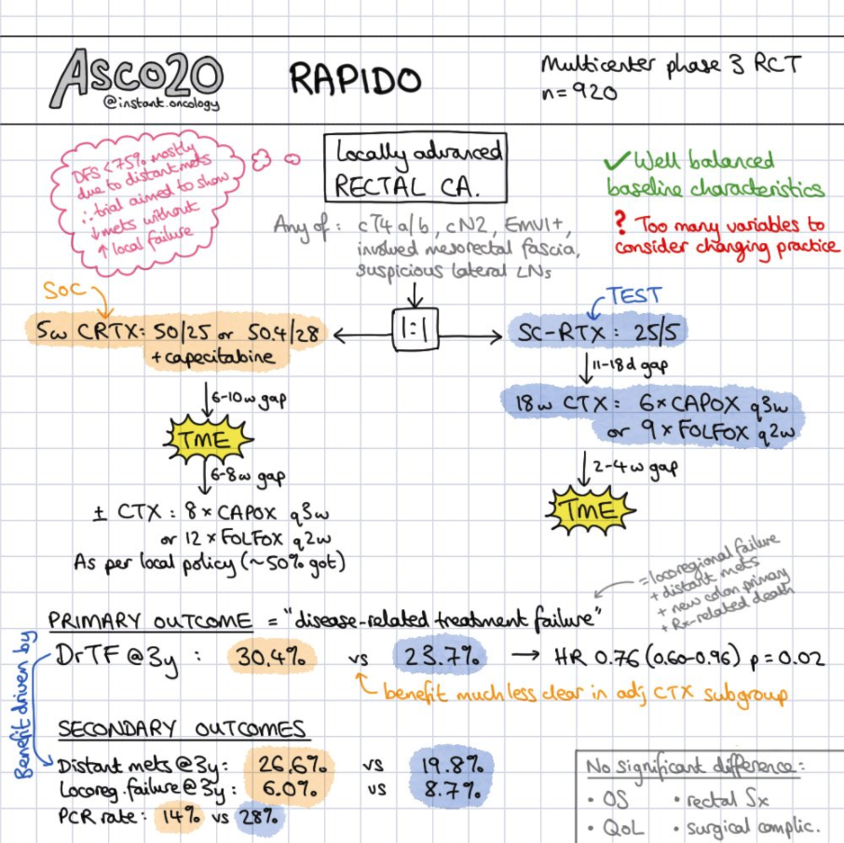](https://www.instagram.com/p/CA3UW_rgzd5/?utm_source=ig_web_copy_link)

* **RAPIDO** [[Marijnen RTO '17](https://www.thegreenjournal.com/article/S0167-8140(17)30871-X/pdf), [van der Valk '20](https://www.ncbi.nlm.nih.gov/pubmed/32240909), [Hospers ASCO '20](https://meetinglibrary.asco.org/record/185464/abstract)]: (**CCRT→ TME→ CTX**) **vs**.(**SCRT→ CTX→ TME**).

Similarly to the [[Spanish GCR-3](https://www.ncbi.nlm.nih.gov/pubmed/25957330)] trial, neoadjuvant chemotherapy has better tolerance than adjuvant chemotherapy. There were no differences in surgical procedures or postoperative complications with SC-RT.

Our take: RAPIDO suggests 25/5 SC-RT→ chemo→ TME should be standard of care over CCRT→ TME. Lower rates of 3y DM and trend to *less* LRF with SC-RT f/b chemo. Caveat: Adjuvant chemo was delivered to 30% less patients in the CCRT arm than the SC-RT→ chemo→ TME arm (i.e., 80% vs. 50% received chemo)

* + 920 high risk pts. T4 (30%), N2, < 1 mm to mesorectal fascia or lateral nodes >1 cm.
    - All TME was performed 4-6 weeks after treatment (chemo in SC-RT, CCRT in the other arm).
    - SC-RT: **25/5→** CAPOX x6c or FOLFOX4 x9c (18w). *All received RT, 84% rec'd at least 75% of chemo.*
    - CCRT: **50.4/X**→ Surgery 4-6w→ Optional adjuvant chemo (CAPOX x8c or FOLFOX4 x12c - 24w).
    - Endpoint: time to disease-related treatment failure.
  + MTT surgery from last RT of 9→ 28w.
  + Full course RT in 94→ 100%, while ≥ 75% completion of Rx'd consolidative / adjuvant chemo in 84→ 57%.
  + pCR 14→ 28%. R0 ~90%.
  + 3y disease-related treatment failure of 30→ 24%. 3y DM 27→ 20%. 3y LRF ~9→ 6% (p=0.1)
  + G3+ toxicity in 50→ 25% preoperatively, while in 35% of patients in CCRT arm receiving adjuvant chemo.
  + There were no differences in surgical procedures or postoperative complications.
* **PRODIGE 23** [[Conroy ASCO '20](https://meetinglibrary.asco.org/record/185485/abstract)]: Phase III. (**50/25/X vs. mFOLFIRINOX x 3 mo→ CCRT**)**→ TME**. 6 mo CTX total.

Neoadjuvant mFOLFIRINOX plus CRT is safe, and significantly increases pCR rate. OS data is still maturing.

Our take: pCR is doubled as compared to "standard" pCR rates for locally advanced rectal cancer (i.e., ~15%). Now, what would happen if CCRT was given prior to mFOLFIRINOX, with 6 mo of neo chemo instead?

* + 230 patients. < 15 cm from the verge. 2012-2016. MFU nearly 4y.
    - Pre-op CCRT alone arm received adjuvant chemo x6 mo, TNT received adjuvant x 3 mo. FOLFOX or X.
  + pCR 12→ 28%.
  + 3y DFS 69→ 76%.
  + 3y DMFS 72→ 79%.
  + 3y OS ~88→ 91% (p=0.08).

[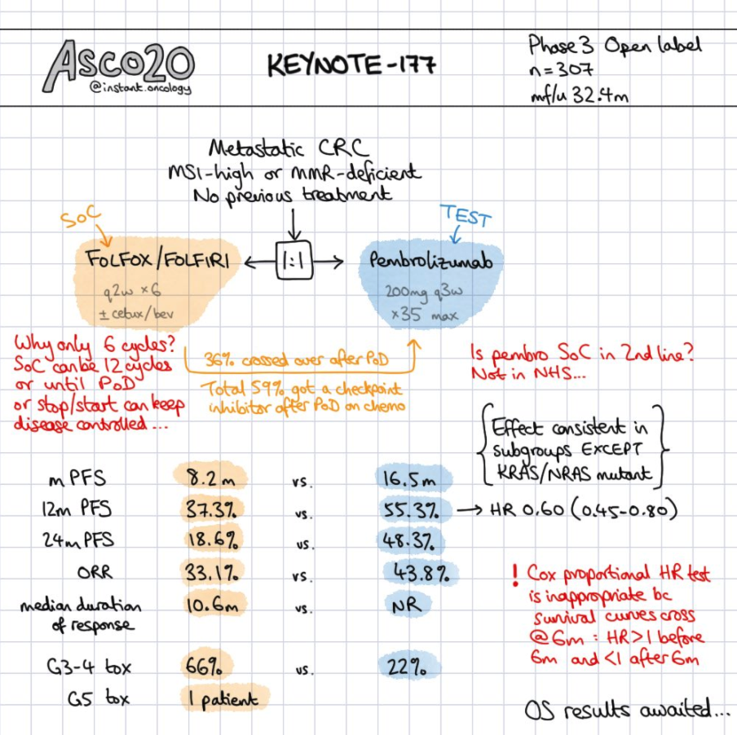](https://www.instagram.com/p/CA3eNXqgoIH/?utm_source=ig_web_copy_link)

* **KEYNOTE-177** [[Andre ASCO '20](https://meetinglibrary.asco.org/record/186928/abstract)]: (**mFOLFOX6 or FOLFIRI ± bevacizumab/cetuximab**) **vs. Pembro**→ Chemo.

TBL [QS1](http://www.quadshotnews.com/2020/05/keynote-177.html),[QS2](http://www.quadshotnews.com/2020/06/mismatched-outcomes.html): Pembrolizumab alone results in significantly better progression-free survival compared to front-line chemo for patients with dMMR/MSI-H advanced colorectal cancer.

Current standard of care, typically, is mFOLFOX followed by FOLFIRI (preferred) or Pembro (usually 2nd or 3rd line).

* + 307 patients. MSI-H/dMMR mCRC. MFU just over 2y.
    - Crossover should have been mandated. Hopefully the control arm received Pembro at progression.
  + MPFS 8→ 17 mo.
  + 1y PFS 37→ 55%. 2y PFS 19→ 48%.
  + Confirmed ORR 33→ 44%.
  + Median DOR 11 mo→ NR.
  + G3-5 AE 66→ 22%.

## Gyn

* **SENTICOL I and II** [[Balaya ASCO '20](https://meetinglibrary.asco.org/record/190091/abstract)]: **Bilateral SLN biopsy vs. bilateral PLND**.

Attempt to uncover unusual lymph drainage patterns. Do bilateral SLN biopsies. Generally, if both negative, ipsilateral lymphadenectomy was preferred.

SLNB alone is oncologically safe in early-stage cervical cancer. Worse prognosis is associated with higher FIGO stage disease.

* + 259 pts. FIGO IA-IIB cervical cancer. 2005-2012. MFU 4y.
  + Tumor size > 2 cm in 11→ 23%. POCCRT in 2→ 11%.
  + 4y recurrence 8%, including 2% nodal recurrence. 4% (n=9) died of cervical cancer.
  + 5y DFS ~94→ 98% (p=0.14). 5y DSS ~88→ 94% (p=0.14).
  + After controlling for final FIGO stage and margin status, SLNB was not associated with DFS and DSS. Only the final FIGO stage was an independent predictor of DSS.
* **STARS** [[Huang ASCO '20](https://meetinglibrary.asco.org/record/185461/abstract)]: **RH/PLND and 1 HR factor→ RT alone vs. CCRT vs. SCRT**.

Sequential SCRT may be preferred for early stage cervical cancer patients with 1 HR factor after radical surgery.

* + 1,048 pts. 2009 FIGO Stage IB1-IIA2 cervical cancer. (75% IB1 or IIA1). MFU 4.5y.
    - CCRT with CDDP 30-40 q1w. SCRT CDDP 60-75 + paclitaxel 135-175 q3w x2c before/after RT.
    - Groups w similar LVSI, grade, rate of minimally invasive surgery. LN involvement lowest in RT alone.
  + 3y DFS 82→ 85→ 90%. Differences remained after adjustment for lymph-node involvement.
  + 5y OS for RT alone / SCRT of ~88→ 92%.
* **DESKTOP III/ENGOT-ov20** [[Du Bois ASCO '20](https://meetinglibrary.asco.org/record/185438/abstract)]: Phase III. **Recurrent ovarian cancer→ ± 2nd cytoreductive surgery**.

Patients who are highly likely to achieve R0 resections may have a survival benefit with 2nd cytoreductive surgery.

* + 407 pts. 2010-2014. Ovarian cancer. Required ECOG 0, ascites < 0.5L, and R0 at initial surgery. PFI ≥ 6 mo.
    - PFI exceeded 12 mo in 75% of patients. *These are highly selected patients!*
  + CR was achieved in 75%, with almost 90% in both arms receiving Plt-containing second-line chemo.
  + MS 46→ 54 mo. MTT first subsequent therapy of 14→ 18 mo.
  + MS among R0 resections of 46→ 61 mo. R1+ resections with MS of 29 mo.
* **NRG GY004** (2016-2017)[[Liu ASCO '20](https://meetinglibrary.asco.org/record/185456/abstract)]: Phase III. **Platinum-based vs. Olaparib ± Cediranib**.

This trial did not select for BRCA mutants, which likely contributed to this being a negative study.

* + 656 pts. Ovarian cancer. PFI > 6 mo. No prior antiangiogenics or PARPi allowed. 24% BRCAmt. MFU 2.5y.
  + 1/3 of patients on the standard of care arm received PARPi maintenance.
  + MPFS ~10 mo.
  + Arms with olaparib and BRCAmt appeared to benefit the most, although not statistically significant.

[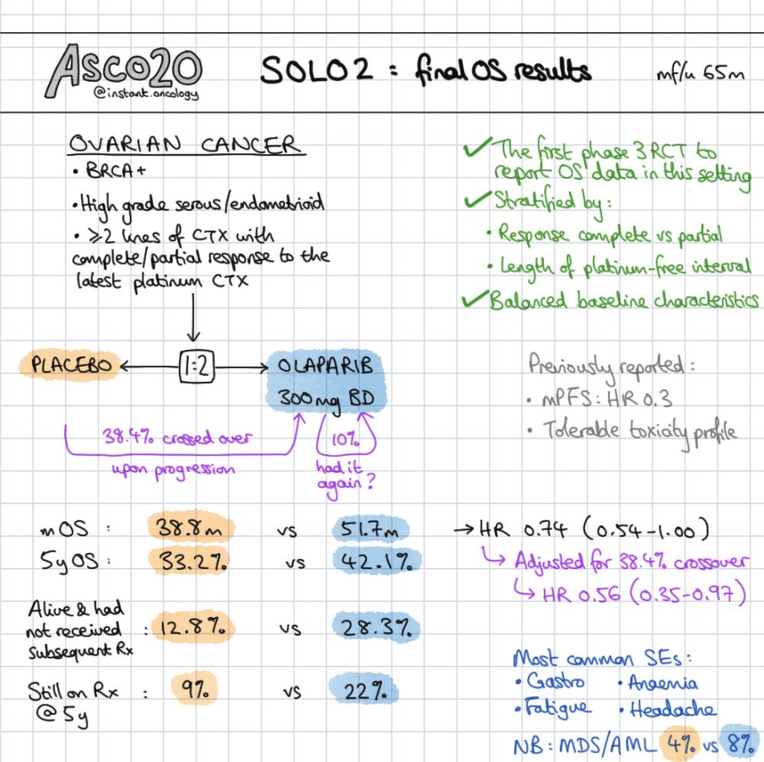](https://www.instagram.com/p/CA0gAgtAGiU/?utm_source=ig_web_copy_link)

* **SOLO2/ENGOT-ov21** [[Poveda ASCO '20](https://meetinglibrary.asco.org/record/185419/abstract)]: Phase III. **BRCAmt. Ongoing Plt response→ ± Olaparib (PARPi)**

When appropriately selecting for platinum sensitive relapsed ovarian cancer, BRCA mutants may see over a year of a survival benefit when given PARPi maintenance.

* + Platinum sensitive recurrent ovarian cancer with ≥ 2 lines of prior tx. MFU 5.5y.
  + MPFS improved 14 months.
  + 5y OS 33→ 42%. MS 39→ 52 mo.
  + 5y alive and without subsequent treatment of 33→ 42%.
* **KEYNOTE-100** [[Matulonis ASCO '20](https://meetinglibrary.asco.org/record/189536/abstract)]: **Pembro** inCohort A (≤ 2 prior lines of chemo) vs. Cohort B (3-5 prior chemo).

There is a modest ORR with Pembro which appears to correlate with higher PD-L1 expression.

* + 376 pts. Epithelial ovarian, fallopian tube, or primary peritoneal cancer with confirmed recurrence following platinum-based therapy. Progression-free interval of 3 mo. MFU 1.5y.
  + ORR for CPS ≥ 1 / ≥ 10 of ~9→ 15%.
    - Median DOR 8→ 24 mo.
  + MPFS 2 mo.

## 

## Non-Prostate GU

* **JAVELIN Bladder 100** [[Powles ASCO '20](https://meetinglibrary.asco.org/record/186872/abstract)]: **Non-progressing after platinum-based chemo→ ± Maintenance Avelumab**.

TBL [QS](http://www.quadshotnews.com/2020/06/alls-well-with-avel.html): Adding maintenance avelumab to unresectable chemo-responsive urothelial cancer dramatically improves survival.

This study did not compare to standard of care, as the control arm was largely deprived of PD-L1 at progression.

* + 700 pts. LA or metastatic bladder cancer without progression after 4-6 cycles of plt-based chemo. MFU 1.5y.
    - PD-L1 positive in 51%.
    - Only 43% of patients who progress on best supportive care received PD-L1 (Standard of care!). 34% get a different drug, and 30% discontinued therapy.
  + MS 14→ 21 mo. MPFS in the control arm was only 2 months!
  + MS for PD-L1 positive tumors of 17 mo→ NR.
  + G3+ toxicity 25→ 47%.
* Oral HIF-2α inhibitors for VHL-associated RCC demonstrate a 28% ORR [[Jonash ASCO '20](https://meetinglibrary.asco.org/record/185945/abstract)]
* **FRACTION-RCC** [[Choueiri ASCO '20](https://meetinglibrary.asco.org/record/185939/abstract)]: Phase II. **Prior progression on PD-1. Nivo 3 / Ipi 1 q3w x4c→ Nivo**.

Nivo/Ipi may provide durable partial response in patients with progression on prior PD-1.

*The abysmal ORR rates suggest a role for consolidative SBRT or the addition of a TKI to ICI (see KEYNOTE 146 below).*

* + 46 pts. Treatment-refractory advanced RCC.
  + ORR 15%. DOR 2-19+ months (n=7), with five patients having an ongoing response.
* **KEYNOTE-146** [[Lee ASCO '20](https://meetinglibrary.asco.org/record/186053/abstract)]: Phase II. **Prior progression on ICI. Lenvatinib + Pembro**.
  + 104 pts. Lenvatinib (dirty VEGFRi). mccRCC.
  + 12w ORR 51%.
  + MPFS 12 mo. DOR 10 mo.
  + Most common AE of fatigue (49%), diarrhea (44%), proteinuria (37%), HTN (31%), nausea (31%), dysphonia (29%), stomatitis (29%), arthralgia (27%).
* **KEYNOTE-426** [[Rini NEJM '19](https://www.nejm.org/doi/full/10.1056/NEJMoa1816714), [Plimack ASCO '20](https://meetinglibrary.asco.org/record/185941/abstract)]: **Sunitinib vs. Pembro + axitinib**.  
  OS and PFS benefit holds true across PD-L1 and even risk groups [QS](http://www.quadshotnews.com/2019/02/advanced-renal.html).
  + 861 pts. Untreated advanced clear cell RCC. MFU over 2y.
    - Sunitinib 50 qd x4w, 2w off. Pembro 200 q3w + axitinib 5 mg BID.
  + 1y OS 78→ 90%. 2y OS 66→ 74%. MS 3y→ NR.
  + ORR 40→ 60%. CR 3→ 9%. Median DOR 24 mo.
  + 2y PFS 27→ 38%. MPFS 11→ 15 mo.
  + G3+ toxicity ~70%.
* **NIVES** (2017-2019) [[Masini JCO '18](https://ascopubs.org/doi/abs/10.1200/JCO.2018.36.15_suppl.TPS4602), [NCT03469713](https://clinicaltrials.gov/ct2/show/NCT03469713), [Masini ASCO ‘20](https://meetinglibrary.asco.org/record/183202/abstract)]: Phase II. **Nivo + 30/3 SBRT after 7 days**.
  + 69 VEGF refractory patients. Endpoint: ORR. Mostly the lung and LN mets were irradiated. MFU 15 mo.
    - Nivo 240 mg q2w x6 mo, then 480 mg q1mo until PD or unacceptable irAE.
  + MPFS 4 mo. G3-4 toxicity 25%. *Compare to 19% on Checkmate 025.*
  + ORR 19%. Disease control 64%.
* **RADVAX RCC** [[Hammers ASCO ‘20](https://meetinglibrary.asco.org/record/183203/abstract)]: Prior therapy allowed. **Nivo 3 / Ipi 1→ Nivo + SBRT to 1-2 sites**.
  + 25 patients. Metastatic clear cell RCC.
  + ORR 56%.
  + Steroids required in 40% (n=10).
* **OZM-053** [[Cheung ASCO '20](https://meetinglibrary.asco.org/record/191148/abstract)]: Phase II. **Oligoprogression on TKI + SBRT** (40/5).

Delivering SBRT to oligoprogressive disease resulted in no need to change systemic therapy for a median of 1 year, effectively increasing the PFS of their TKI therapy.

* + 37 patients. Previous stability or response on ≥ 3 mo of TKI who developed progression in ≤ 5 mets. MFU 1y.
  + Median duration of TKI of 19 mo. Solitary olioprogressive in 21, while 2-3 oligoprogressive in 17.
  + 2y LC 96%.
  + Cumulative incidence of changing systemic therapy at 1 / 2y of 47→ 75%.

## 

## Prostate

* **PSMA-PET pre-operative nodal staging** [[Hope ASCO '20](https://meetinglibrary.asco.org/record/187068/abstract)]: Phase III. **PSMA N+ with pathologic confirmation**.

Pelvic nodal metastasis are detected with a high specificity, while sensitivity was most reasonable for nodes ≥ 1 cm.

* + 633 pts. 44% (n=277) underwent RP and PLND. Median PSA 11. 27% pN1.
  + PSMA nodal Se / Sp / PPV and NPV for N1 detection of 0.40→ 0.95→ 0.75→ 0.81.
  + Sensitivity for N1 disease with PSA ± 11 of 0.29→ 0.48.
  + Sensitivity for N1 disease with nodes ± 1 cm of 0.3→ 0.68.
  + Average node side in true positive patients was 10 mm vs. 4 mm in false negative patients.
* **CONDOR** [[Morris ASCO '20](https://meetinglibrary.asco.org/record/187017/abstract)]: **18F-DCFPyl-PET/CT** (binds selectively with high affinity to PSMA).

PSMA-targeted PyL-PET/CT detected and localized occult disease in most men with bCR presenting with negative or equivocal conventional imaging, leading to changed management plans in the majority of patients.

TBL QS: PSMA-PET for initially radiographic elusive biochemically recurrent prostate cancer has a huge impact on determining appropriate management.

* + 208 men, recurrence < 2 ng with negative or equivocal standard of care imaging (e.g., CT/MRI, NM bone scan).
    - Correct localization rate (CLR): Requires at least 1 lesion to correlate with path, imaging or PSA response.
  + CLR ~85%.
  + PSMA-avid lesions identified in 69% of patients.
  + 64% had change in intended management after PyL-PET/CT, of which nearly 80% attributable to positive findings.
* **TheraP** [[Hofman ASCO '20](https://meetinglibrary.asco.org/record/187000/abstract)]: Phase II. **Progression on prior Docetaxel→ Cabazitaxel vs. LuPSMA**.

TBL [QS](http://www.quadshotnews.com/2020/06/select-outcomes.html):Therapeutic Lu-177-PSMA resulted in better PSA response than cabazitaxel with docetaxel-treated mCRPC, but the kicker is they could have no evidence of FDG-positive/PSMA-negative disease on imaging.

Finally, some clinical data for theranostic LuPSMA! The TheraP trial suggests the superiority of LuPSMA over cabazitaxel in mCRPC in patients progressing after docetaxel.

* + 200 of 291 PET-screened men. mCRPC. Lu-177. MFU nearly 1y.
  + PSA50-RR 37→ 66%.
  + Grade III-IV AE in 49→ 32%.

## H&N, Thyroid

* **SentiMERORL** [[Garrel ASCO '20](https://meetinglibrary.asco.org/record/187458/abstract)]: **Primary resection (OC/OP) pT1-2→ LND vs. SLNB**.

"SLNB is established as standard of care in pT1-2N0 OC/OP patients"

This is a pretty ballsy claim as DOI > 2 mm for OC is traditionally associated with > 15% LN metastasis.

* + 279 patients. Oral cavity and oropharynx.
  + 2y neck RFS of ~90%. 5y neck RFS of ~89%.
  + No differences in functional outcomes at 12 mo or later.
* **JCOG1008** [[Kiyota ASCO '20](https://meetinglibrary.asco.org/record/187232/abstract)]: Phase II/III Non-inferiority. **CDDPRT 100 q3w vs.** **CDDPRT 40 q1w**.

CDDP 40 q1w is non-inferior to CDDPRT 100 q3w. Should this be the standard of care?

Thought-provoking data suggesting CDDP 40 q1w should be standard over 100 q3w for H&N POCCRT. Albeit a non-inferiority study, we're still trying to piece together why there may even be an RFS and OS benefit despite a lower median total dose of weekly CDDP.

CDDP 40 q1w is non-inferior to CDDPRT 100 q3w. Should this be the standard of care?

* + 261 pts. 2012-2018. R1 and/or ENE. MFU 2.2y
  + 3y OS ~59→ 71%.
  + 3y RFS 53→ 65%.
  + Median total dose of CDDP of 280→ 239 mg/m2.
  + Treatment completion in 93→ 87%.
* **CRUK/14/014** [[Nutting ASCO '20](https://meetinglibrary.asco.org/record/186722/abstract)]: Phase III. **IMRT ± Dysphagia optimization** (Do-IMRT).
  + 112 pts. T1-4N0-3M0 OP/HPX cancer. 97% OPC. 84% received CCRT.
    - IMRT 65/30 to primary and nodal tumor, 54/30 to remaining pharyngeal subsites and nodal basins.
    - Do-IMRT sets a mandatory mean constraint to the S/MPC (OP) and IPC (HPX) outside CTV1.
  + Median of the mean IPC of 50→ 28 Gy.
  + Median of the mean S/MPC of 57→ 50 Gy.
  + 1y MDADI of 70→ 78.
* **ECOG 3311** [[Ferris NCT01898494](https://clinicaltrials.gov/ct2/show/NCT01898494.), [ASCO '20](https://meetinglibrary.asco.org/record/187340/abstract)]: Uses surgery to risk stratify. Not a true de-escalation trial.  
  Goal: Get rid of chemo with surgery in the context of ECE. We are preselecting patients, as 4+ LN receive chemotherapy. Therefore, do not take to surgery if 4+ lymph nodes! See the [[basis of TORS](https://docs.google.com/document/d/1STZuiggtbkDIuuNMpDVSsqT2KMyp1017y8qV5Gz_GGc/edit#bookmark=id.xp1rna8u8muk)] section for more.

TBL [QS](http://www.quadshotnews.com/2020/06/tors-down.html): You should feel good enrolling a patient on a phase 3 trial examining TORS + 50 Gy post-op radiation as deescalated therapy for intermediate-risk HPV(+) oropharyngeal cancer.

Our take: Base hit? ECOG 3311 demonstrated no 2y PFS detriment for intermediate-risk patients (≤ 1 mm ECE, SM-, 2-4 LN) treated with 50 Gy vs. 60 Gy PORT. Looking forward to seeing 1-year MDADI for TORS→ 50 Gy PORT vs. CCRT in the planned phase III trial.

* + 519 OP patients. 2013-2017. cT1-2 stage III/IV AJCC7 without matted neck nodes. MFU 2.5y.
    - **Low risk** (n=37): T1-2, 0-1 LN, no PNI/LVI→ **Obs**.   
      *Home run!*Less overall toxicity with TORS alone vs. CCRT. These pts are also candidates for [[RT alone](https://docs.google.com/document/d/1STZuiggtbkDIuuNMpDVSsqT2KMyp1017y8qV5Gz_GGc/edit#bookmark=kix.85g3nwhuj8yw)].
    - **Int risk** (n=206): ≤ 1 mm ECE, SM-, 2-4 LN, PNI/LVI→ **PORT 50/25 vs. 60/30** DAHANCA-style.  
       *Base hit?* Is TORS→ PORT alone to 50/25 or 60/30 with less toxicity than 70 Gy CCRT? If the 50 Gy arm is equivalent to 60 Gy, then that pushes the toxicity down on the TORS arm and it is likely to be less toxic than definitive CCRT.
    - **High risk** (n=110): > 1 mm ECE (76%), > 4 LN (27%), SM+ (11%)→ **POCCRT** 60-66/33/CDDP 40 q1w.  
       *Strike out!* Worse toxicity with TORS and 66 Gy CCRT vs. 70 Gy without TORS.
  + 2y PFS for LR of 94%.
  + 2y PFS for IR PORT 50/25 vs. 60/30 of ~95%.
  + 2y PFS for HR of 91%.
* **AxitinibACC** [[Keam ASCO '20](https://meetinglibrary.asco.org/record/187174/abstract)]: Phase II. Recurred, metastatic ACC. **± Axitinib**.

This is an extremely short follow up for ACC. Is there finally an "effective" systemic agent for adenoid cystic? Axitinib dons its boxing gloves, but the jury is certainly still out as we need to see how durable those gloves are with longer (e.g., 10y) of follow up.

* + 60 pts. Progression within 9 mo. Crossover permitted for patients in obs arm with disease progression. MFU 2y.
  + 6 mo PFS 23→ 73%.
  + MPFS 3→ 11 mo.
  + ORR 0→ 3%. After crossover, ORR was 11%.
  + Disease control rate 0→ 100%.
  + MS ~28 mo→ NR.

## 

## Skin

* Melanoma: The first two doses of Nivo 1 + Ipi 3 appears to drive efficacy and toxicity [[Postow ASCO '20](https://meetinglibrary.asco.org/record/185691/abstract)]
* Melanoma: Combined ICI appears to be the way to go, as it appears effective even if refractory to mono-ICI [[Da Silva ASCO '20](https://meetinglibrary.asco.org/record/185644/abstract)]
* Melanoma: Ipi 1/Nivo 3 x2c appears to be able to avoid LND in the setting of major pathologic response [[PRADO Blank ASCO '20](https://meetinglibrary.asco.org/record/185836/abstract)].
* **COMBI-AD** [[Long NEJM '17](https://www.nejm.org/doi/full/10.1056/NEJMoa1708539), [Dummer Lanc Onc '20](https://www.thelancet.com/journals/lanonc/article/PIIS1470-2045(20)30062-0/fulltext), [ASCO '20](https://meetinglibrary.asco.org/record/185662/abstract)]: **Stage III R0→ Placebo vs. Dabrafenib + Trametinib**.

Adjuvant dabrafenib and trametinib improves RFS by around 20%, with suggested (and likely) 10% improvement in OS.

TBL [QS1](http://www.quadshotnews.com/2017/09/new-england-journal-of-melanoma.html), [2](http://www.quadshotnews.com/2020/02/high-low.html): Tumor mutation burden and T-cell inflamed gene signature predict response to BRAF-targeted therapy, in addition to immunotherapy, and can thus help guide treatment sequencing for stage III melanoma.

* + 870 pts. 2013-2014. Resected stage III melanoma with V600E or V600K mutations. MFU 5y.
  + Roughly 1/3 of patients had a high tumor mutational burden, which was strongly associated with V600K mutation. A high TMB was also prognostic of better RFS among patients treated with placebo, but interestingly not among those treated with D/T. In contrast, high IFN-Ɣ signature was prognostic of better outcome regardless of treatment. While TMB-high / IFN-high melanoma had the best outcomes overall, TMB-low / IFN-high derived the greatest benefit from targeted therapy.
  + 3y RFS 39→ 58%. 5y RFS 36→ 52%. *Recurrences are rare after 3y.*
  + MDMFS was NR in either arm, but favored BRAF/MEKi.
  + 3y OS 77→ 86%, but did not cross the prespecified interim analysis boundary.
* **EORTC 1325** [[Eggermont NEJM '18](https://www.nejm.org/doi/full/10.1056/NEJMoa1802357), [ASCO '20](https://meetinglibrary.asco.org/record/185762/abstract)]: **Stage III R0→ Placebo vs. Pembro** 200 q3w x18c (1 year).  
  Pembro improves RFS in resected stage III Melanoma.
  + 1,019 pts. Stage IIIA+ (at least one LN mets > 1 mm), IIIB, or IIIC (without in-transit mets). MFU 3y.
  + 1y RFS 61→ 75%. 3y RFS 44→ 64%.
  + PD-L1 positive (n=853): 3y RFS 46→ 65%.
  + PD-L1 negative (n=116): 3y RFS 33→ 57%.
  + The only group that appeared not to benefit from Pembro was Stage IIIA, which was likely due to low numbers. BRAF mutated and BRAF wild appear to share benefits of the same magnitude.
  + G3+ AE 3→ 15%.

## Heme

* **ENDURANCE** [[Kumar ASCO '20](https://meetinglibrary.asco.org/record/186906/abstract)]: **Lenalidomide/Dexamethasone +** (**Bortezomib vs. Carfilzomib**).

TBL [QS](http://www.quadshotnews.com/2020/06/embrace-status-quo.html): Carfilzomib failed to additionally improve either progression-free or overall survival, meeting futility at its second planned interim analysis. In other words, bortezomib + lenalidomide + dex remains standard initial therapy for most multiple myeloma.

* + 1,087 pts. Refractory MM. Excluded del17p,t(14;16), t(14;20), plasma cell leukemia, and high-risk GEP70 profile.
  + MPFS ~34 mo.
* **KEYNOTE-204** [[Kuruvilla ASCO '20](https://meetinglibrary.asco.org/record/186007/abstract)]: Phase III. **Brentuximab-vedotin** (BV) **vs. Pembro**.

Another victory for Pembro in the HL realm. Does it blow anyone else's mind that these pts could have received hundreds of thousands of dollars worth of systemic therapy without ever having seen RT? Don't even get us started on [[ECHELON-1](https://docs.google.com/document/d/1gKy2Hpx7FxInjOpKIBkTFJWpqhJ3I-gSXz9eRwq-NSY/edit#bookmark=id.zgtm6b5xf2vm)] for stage III-IV HL. ABVD x6c costs $4,000, while ABV + BV costs $300,000 for a measly 5% PFS benefit at 2 years. What PFS benefit does RT add? Likely 5-10%, for a fraction of the cost of these agents. We suggest RT should be employed more often in the up-front and refractory setting, even for advanced disease. Initial bulk > 7 cm, and more importantly residual disease > 1.5-2.5 cm, should be taken into account regardless of PET response. [RoR](https://docs.google.com/document/d/1gKy2Hpx7FxInjOpKIBkTFJWpqhJ3I-gSXz9eRwq-NSY/edit#bookmark=id.2umqw59gv3o3)

* + 300 patients. Relapsed/refractory auto-SCT or ineligible for auto-SCT. Prior BV allowed (n=15). MFU 2y.
  + Median time of treatment 146→ 305 days.
  + MPFS 8→ 13 mo.
  + 12 mo PFS 35→ 54%.
  + ORR 54→ 66%. CR ~25%.
  + Median DOR 14→ 21 mo.
* Down syndrome children with B-ALL have increased relapse and toxicities [[Rabin ASCO '20](https://meetinglibrary.asco.org/record/185872/abstract)].
* **RTOG 1114** [[Omuro ASCO '20](https://meetinglibrary.asco.org/record/185073/abstract)]: Phase II. **R-MPVx5-7c (80% CR)→ ± WBRT (23.4/13 if CR)→ Ara-C x2c**.

When is rdWBRT going to be seriously considered as first-line for PCNSL?

* + 91 patients. PCNSL. Median age on WBRT arm nearly 70y! MFU 4.5y.
  + Median ITT PFS 25→ NR. 2y PFS 54→ 78%.
  + MS NR in either arm, with data still maturing.
  + Clinically defined moderate to severe neurotoxicity of ~11→ 14% (p=0.75)

## Sarcoma / Musculoskeletal

* **MDACC** [[Roland ASCO '20](https://meetinglibrary.asco.org/record/185571/abstract)]: Phase II. Neo **Nivo ± Ipi for surgically resectable RP-DDLPS or extremity/trunk UPS**.

UPS appears exquisitely sensitive to ICI! Too bad we have to wait until 2025 for results of SU2C-SARC032 (Neo Pembro+RT), but it's amazing to see progress in the realm of sarcomas and systemic therapy.

* + 24 patients.
  + Median path response in the UPS cohort was 95%, while 22.5% in the DDLPS cohort.
  + 8 patients with path response ≥ 85%, including 1 PR, 5 SD and 2 PD by RECIST criteria.
* MEKi (binimetinib) in addition to imatinib may improve response rates in advanced GIST [[Chi'ASCO '20](https://meetinglibrary.asco.org/record/185566/abstract)]
* **SSGXVIII/AIO** [[Joensuu ASCO '20](https://meetinglibrary.asco.org/record/185568/abstract)]: **R0→ Imatinib for 1y vs. 3y**.

About 50% of deaths can be avoided during the first decade of follow up after surgery with 3y of imatinib.

* + 400 pts. MFU 10y.
  + 5y RFS 53→ 71%. 10y RFS 42→ 53%.
  + 5y OS 86→ 92%. 10y OS 65→ 79%.

## Thorax

* **ADAURA** [[Herbst ASCO '20](https://meetinglibrary.asco.org/record/191929/abstract)]: **R0/1→ ± Osimertinib** x3y **after optional adjuvant systemic therapy**.

TBL [QS](http://www.quadshotnews.com/2020/06/adaurable.html): The face of adjuvant therapy for resected NSCLC has changed with the addition of the targeted therapy osimertinib proving to dramatically extend life without recurrence. See the [[PACIFIC](https://docs.google.com/document/d/1oKD3L5ieCk03FWU6fCnj8aiHKRPJD-q6IpjXpQCuexw/edit#bookmark=id.xpwgdlid9n6k)] trial.

It is likely that brain staging with CT was acceptable and PET/CT was not mandated. By including patients not staged with standard of care, this trial may include occult metastatic disease which favors adjuvant treatment.

When patients in the control arm progressed, did they receive osimertinib? Seems doubtful.

* + 682 patients. Non-squamous EGFR exon 19 del/L858R. Stage IB-IIIA NSCLC (31% IB, 69% II/IIIA).
  + 2y DFS for stage II-IIIA patients of 44→ 90% (HR 0.17).
  + 2y DFS in the overall population of 53→ 89% (HR 0.21).
* **SINDAS** (2016-2019) [[Wang ASCO '20](https://meetinglibrary.asco.org/record/187450/abstract)]: Phase III. **TKI ± up-front SBRT to all sites of disease**.

The SINDAS trial for EGFRmt NSCLC suggests an overall survival benefit of 9 months for up-front SBRT to ≤ 5 oligo sites in addition to a TKI! Too bad OS wasn't doubled as suggested in OligoGomez, but hey, Phase III data is always nice!

TBL QS: While we await details of the full pub, this preliminary reporting adds significant fuel to the excitement of upfront consolidative therapy for oligometastatic EGFR-mutated NSCLC—even in the era of TKIs.

* + 133 pts. EGFRmt. ≤ 5 metastatic sites. Systemic therapy naive. No brain mets. MFU 1.5y.
  + MPFS 13→ 20 mo.
  + MS 17→ 26 mo.
  + G3-4 RP ~3→ 7% (p > 0.05), G3-4 esophagitis ~4%.
* **Checkmate 227** [[Hellmann NEJM '18](https://www.nejm.org/doi/full/10.1056/NEJMoa1801946), [Ramalingam ASCO '20](https://meetinglibrary.asco.org/record/184651/abstract)]: **Chemo vs. Nivolumab ± Ipilimumab**.   
  ORR doubled with the addition of Ipi to Nivo vs. chemo; though Tx-related AE leading to discontinuation also doubled.
  + Stage IV or recurrent NSCLC, chemo naive. Irrespective of PDL1 or histo. MFU nearly 4y.
    - For those < 1% PD-L1, Chemo vs. Chemo/Nivo vs. Nivo/Ipi. *Nivo alone is not given if < 1% PD-L1.*
  + High mutational burden subset (≥ 10 mutations/megabase):
    - For chemo vs. Nivo+Ipi: 1y PFS 13→ 43%. MPFS 6→ 7 mo. ORR 27→ 45%.
    - Benefit persists for < 1% PD-L1.
  + Low mutational burden subset (< 10 mutations/Mb):
    - For chemo vs. Nivo+Ipi: 1y PFS ~17→ 25% (NS), MPFS 5.5→ 3.2 (NS).
  + For PD-L1 ≥ 1%, 3y OS 22→ 29→ 33%. 3y PFS 4→ 12→ 18%. Confirmed responders remaining in response 4→ 32→ 38%.
  + For PD-L1 < 1%, 3y OS 15→ 20→ 34%. 3y PFS 2→ 8→ 13%. Confirmed responders remaining in response 0→ 15→ 34%.
  + PFS is not better with Nivo alone in any subgroup.
  + Patients with PD-L1 ≥ 1% with ≥ PR at 6 mo had longer subsequent survival with Nivo/Ipi than chemo, but patients with SD or PD at 6 mo had generally similar subsequent OS between treatments.
  + Toxicity quite significant of Ipi/Nivo, similar to platinum based chemo:
    - G3-4 36→ 19→ 31%.
    - Tx-related AE leading to discontinuation: 5→ 7→ 12%. *Essentially doubled.*
* **CheckMate 9LA** [[Reck ASCO '20](https://meetinglibrary.asco.org/record/184688/abstract)]: **Chemo x4c vs. Nivo 360/Ipi 1 + Chemo x2c→ maintenance ICI**.
  + 700 pts. Stage IV or recurrent NSCLC. No targetable mutations. MFU 13 mo.
  + MS 11→ 16 mo.
  + 1y OS 47→ 63%.
  + G3-4 AE 38→ 47%.
* **THORA** [[Gronberg ASCO '20](https://meetinglibrary.asco.org/record/184539/abstract)]: Phase II. **45/30 BID vs. 60/40 BID with CE x4c**.

Ahh, the classic OS benefit without a PFS benefit. What to do with this information…? Final pub will be interesting.

* + 176 pts. 2014-2018.
  + MPFS ~14→ 20 mo (p=0.31).
  + 2y OS 46→ 73%. MS 23→ 42 mo.
  + G3-4 esophagitis ~20%. G3-4 pneumonitis ~0→ 4% (p=0.1)
* **ECOG-ACRIN EA5161** [[Leal ASCO '20](https://meetinglibrary.asco.org/record/184553/abstract)]: **Platinum/Etoposide** x4c **± Nivo**.

Small number of patients, short follow up. Atez and Durva will likely hold the front lines in this setting - at least for now.

* + 160 patients. ES-SCLC. First line! PCI at discretion.
  + MS 9→ 11 mo.
  + ORR 48→ 52%.
* **KEYNOTE-604** [[Rudin ASCO '20](https://meetinglibrary.asco.org/record/184545/abstract), [JCO '20](https://ascopubs.org/doi/10.1200/JCO.20.00793)]: **Platinum/Etoposide** x4c **± Pembro**. PCI at clinician discretion.

Pembro in addition to traditional chemo only prolongs OS in the as-treated analysis, not ITT. This won't be the first line.

TBL QS: Pembro, unlike atezo and durvalumab, does not improve survival when added to front-line platinum and etoposide for metastatic small cell lung cancer.

* + 453 pts. ES-SCLC. First line! No untreated brain mets (~12%). PCI in 13% (only if PR/CR). MFU nearly 2y.
  + ITT MS ~10→ 11 mo. *Did not meet significance threshold.*
  + ORR 60→ 70%.
* **KEYNOTE 799** [[Jabbour ASCO '20](https://meetinglibrary.asco.org/record/185983/abstract)]: Phase II. **CCRT with Pembrolizumab** up to 1 year.

Pembro with CCRT demonstrates promising anti-tumor activity. Toxicity was as anticipated. Enrollment continuing for CisPem arm.

* + 195 patients (112 CarboP, 73 CisPem). Unresectable Stage III NSCLC. MFU 8 mo.
    - RT 60/30 given with C2 of Pembrolizumab.
    - Investigators choice CarboP or CDDP/Pemetrexed (AC only).
  + ORR for CarboP / CisPem of 67→ 57%.
  + Median DOR NR.
  + G3+ Treatment-related AE for CarboP / CisPem of 64→ 41%.
  + G5 RP in 5 patients, all in the CarboP arm.
* **KEAP1/NFE2L2 predict for local recurrence after RT but not surgery** [[Binkley ASCO '20](https://meetinglibrary.asco.org/record/188280/abstract)]:
  + 232 patients with localized NSCLC. 47 LA-NSCLC received CCRT, 50 ES-NSCLC received SBRT.
  + 2y LR in the combined RT cohort for K-Nwt / K-Nmt of 13→ 42%.
* **Molecular subtypes and clinical outcomes to initial systemic treatment in SCLC** [[Lai ASCO '20](https://meetinglibrary.asco.org/record/184549/abstract)]:

Differential expression of the transcription regulators ASCL1 and NeuroD1 can be used to define molecular subtypes of SCLC. Molecular subtypes defined by ASCL1 and NeuroD1 may predict patient outcomes.

* + 281 patients with SCLC. IHC performed to assess ASCL1 and NeuroD1 expression.
  + 6 mo PFS for A-N- (n=4) / A-N+ or A+N- (n=15) / A+N+ of 25→ 60→ 55%.